Spatiotemporal dynamics of cod and snow crab in the Bering Sea

(once we see the results maybe something bangier like “Rising temperatures disrupt dynamics of linked fisheries in the Bering Sea”…if the data send us that way…)

I’d like to suggest at least two other individuals that could make useful contributions. Kirstin Holsman (likes crab and cod…does ecosystem modeling and climate stuff at the AFSC…and Jim Thorson (author of VAST…and a bunch of other stuff)

Not trying to make this list of people too large, but I think it might be great to add my labmate Alexa (Fredston-Hermann) to this list as well. She is a biogeographer and climate change ecologist, and has worked with trawl and environmental data a lot. I think there’s enough here for multiple papers—maybe if we have a quorum of people we can pursue multiple simultaneously.

Summary problem statement:
Cod and snow crab are two of the largest and most lucrative fisheries in the eastern Bering Sea, but both have experienced declines in abundance compared to historical levels. Cod is a known predator of juvenile snow crab and the fraction of snow crab in stomach contents of cod can exceed XX%. Bottom temperature is also known to influence the dynamics of both species. Here we examine the relationship between cod and snow crab population dynamics using spatiotemporal models and empirical dynamical modeling.

Key questions:
Can we tease out the relative influences of predation, temperature, fishing, and intraspecific dynamics on the changes in stock size and distribution?
What are the relationships between snow crab recruitment, cod biomass, and the cold pool?
“Multiple stressors and multiple contingency”: is the contraction of the adult crab stock in the 1990s best explained by a combination of cold pool and cod predation? If so, even with a reduction in the cod stock (a reduction of a threat), does the environment keep crab confined to the northwest?
What are the key drivers of population dynamics for these linked, exploited species?
Does cod recruitment follow crab recruitment or does crab recruitment follow cod spawning biomass?
What should we expect for these two species in the future given projections of climate change?

The climate change paper seems like the obvious choice to split out into a second paper. However, given the prevalence of the environmental ratchet (if we find further evidence of it), the natural inclination would be to include ‘future projection’ into any discussion of drivers of abundance and distribution.

Key intro points:
Commercially important species and potentially environmentally sensitive.
Cod collapses elsewhere.
Previous overfished declaration for snow crab.
Current overfished declaration for other crab fisheries in the Bering Sea.
Nasty downward trend for cod in the Bering Sea (lowest estimated biomass on record last year, I believe)
Changes in spatial distribution for both cod and snow crab (see Orensanz et al. “Environmental ratchet hypothesis” for snow crab)

What are the relationships between environmental conditions, snow crab abundance (recruits and spawners), and cod abundance (recruits and spawners)? (use EDM)
Do these perceived relationships change when the spatial component is considered? (use VAST)

This is perhaps two different papers. I personally think the spatiotemporal aspect is much more interesting (and will probably tell a more convincing story), but since you have the EDM stuff dialed in, it would be easy to do the comparison. I think if I was shooting for a higher journal, I’d just use one method and go hard on the story, which would probably take more time owing to message crafting. If I was fine with just doing a quick comparison and wanted to shoot lower, I’d run the two methods and talk about their differences, and call it a day.

Methods
Data
National Marine Fishery Service summer bottom trawl survey. I’ve placed both of these files in the ‘data’ folder in the repo. I have some code that pulls together the snow crab data into a format that can be used in VAST. You can probably adapt it for cod (I haven’t played with those data).

You will need to calculate several metrics from the survey data—I’ve dropped some thoughts on those below.

Snow crab recruitment: two ways to think about this. First, we could just take the estimated recruitment from the assessment. Second we could take the observed recruitment from the survey. There are differences in these time series (for a couple of reasons we can discuss later). If this was only an application of EDM, I would say just use the assessment estimates. However, with the spatial component, things get more complicated. Aside from just using the observed recruitments (e.g. the area swept estimates of crab from 27.5-42.5 mm carapace width), we could also normalize these estimates by the assessment estimates of crab in a given year to get the ‘total’ recruitment when summed over space to give the same number as the assessment estimates.

Snow crab spawning biomass suffers somewhat less than recruitment for these sorts of issues, but we might have to take a similar approach as above.

I’m less familiar with the differences between the observed and estimated recruitment for cod, but we should also plot the raw estimates of each category against the assessment estimates to get an idea of what sorts of differences we see.

The bottom temperature is reported for each tow in the snow crab survey data file, but you will need to write some code to get the aggregate bottom temperature and …?

Fishing data?? Spatial catch, effort?

EDM
You already have text to put here.

VAST
Look at the literature folder for “Thorson et al 2016 Joint dynamics species distribution models” for sources. There will be a fair number of other sources that are useful, but that’ll get you started.

Future projections
We have a variety of projections from global climate models at the AFSC. Kirstin is heading a group focused on this. Once we get to this point, we can chat more.

To do (we can drop all of this into the issue tracker on github, if that’s easier):
--Produce a ‘massaged’ data file similar to ‘opi_dat.R’ for cod
--Produce time series of the aggregate metrics to be used in the analysis (i.e. snow crab mature female biomass, mature male biomass, recruitment, cod spawning biomass, exploitable cod biomass, cod recruitment, bottom temperature)
--Produce plots to check the differences between the assessment estimates and observed of quantities to be used in the analysis
--If differences are large, decide which time series to use.
--If the time series to use is the assessment, produce code to rescale the observed spatial densities by year using the assessment estimates.
--Initial data exploration—produce maps/gifs of distributions over time, compare the aggregate metrics (e.g. pairs(), EDM, ccf(), etc., etc.)
--Produce the input files for VAST for each quantity in the analysis.
--Apply VAST
--Literature review

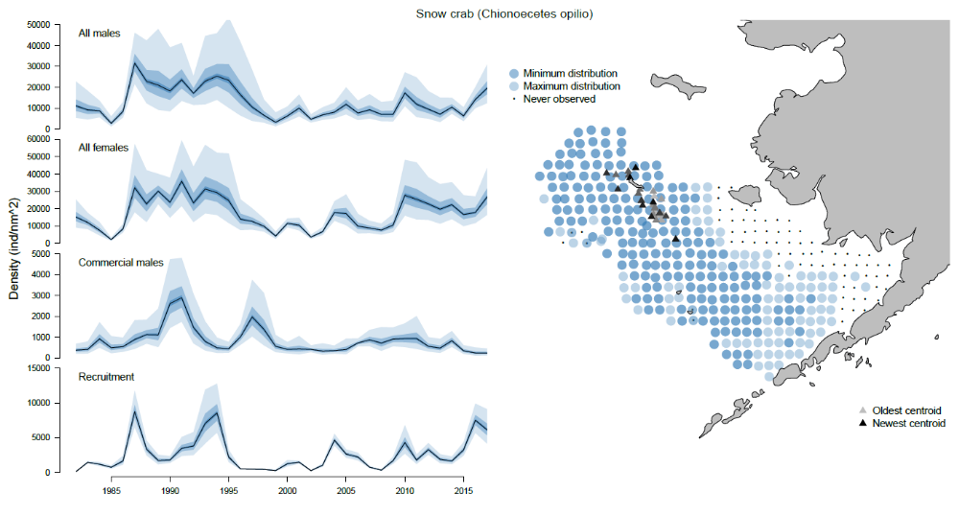
Figure 1. Time series of snow crab recruitment and spawning biomass and spatial distribution extremes. (Similar to the above, but a bit different…this is a draft figure from a different paper…super fuzzy for some reason and needs bigger text for sure!)

Figure 2. Time series of cod recruitment and spawning biomass and spatial distribution extremes. (Similar to above).
Figure 3. Time series of size of cold pool/bottom temperature, and spatial distribution extremes. (Similar to above). If you shoot for a four figure journal, figures 1-3 could be combined relatively easily, I think.
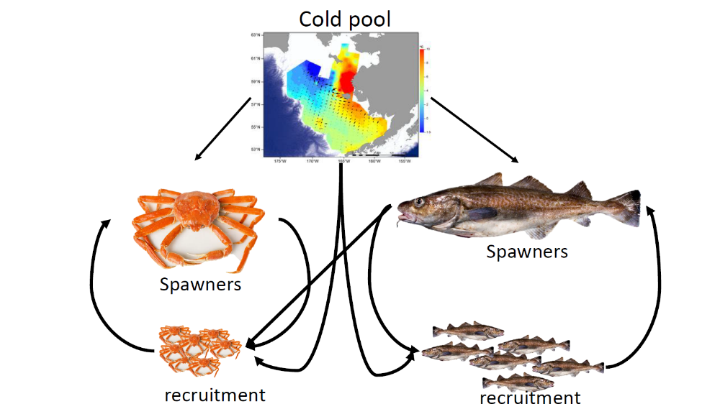
Figure 4. Flow chart of the magnitude and direction of relationships between each of the components (less crappy than this, but you get the picture—this could probably more easily be done with a table).

Figure 5. Same relationships, but from VAST.

